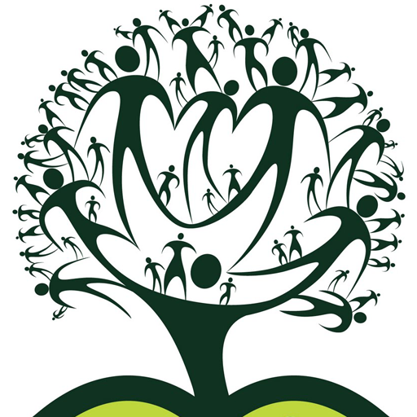

A Better World

Many of us would like to make the world a better place if only we knew how?

FREE workshops on Community Engagement

Modules will depend on the participants but may include the following:

25th April - How to Support Bees and other Irish endangered species

02nd May - Eating from the wild – gathering food and recipes

9th May - Self-Expression (Stone Art/Music/role-playing/flowers/writing or anything else the group might prefer)

16th May - Local services and how to help including Adopting a Patch

23rd May - Multiculturalism through food and music

30th May - Reducing your carbon footprint (and your bills)

6th June - Preventing poor-health – taking best care of yourself and others

13th June - Getting somewhere with your County Council - who are the useful names and what are their direct telephone numbers

Start date: Tuesday 25th April
Tuesdays 1.30pm-3.30pm
Baldoyle Community Hall (Portacabin)
Cost: FREE

Register by contacting us on 01 8395338, email: info@baldoyleforum.ie or download the registration form from www.baldoyleforum.ie or just turn up!

Free Tea/Coffee & Biscuits every week along with other FREE ‘gifts’
Places limited but people are welcome to choose what days they’d like to attend.

Sponsored by Educational Training Board (ETB) and Baldoyle Forum Clg



